Draft for Discussion (v0.3)

LibRWRI: The Anti-Fragile Library for a Convex Life

Dave Dyke, Kat Maunders

12th March 2020

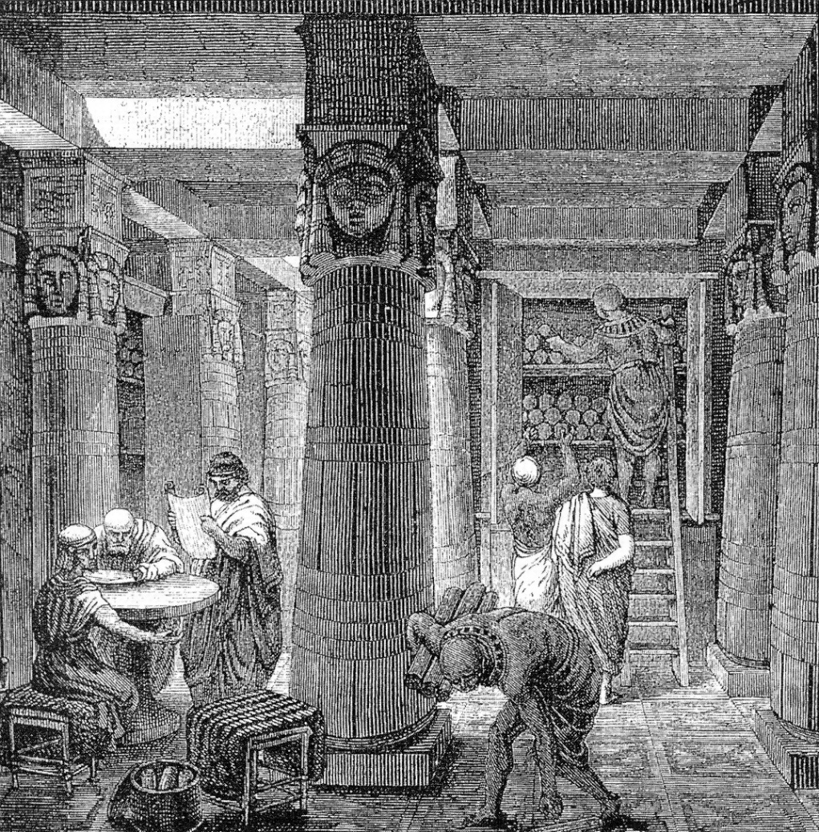

# Purpose of this paper, acknowledgements & brand

This draft paper is to kick-start a discussion with a small group of RWRI alumni who would like to develop the concept of *Knowledge for a Convex Life.* Throughout we refer to principles, research, ideas and intellectual property of Nassim Taleb & his colleagues at Real World Risk Institute LLC. Furthermore, the working title of this – The LibRWRI – clearly infringes on their brand. Before this is circulated more broadly, we need RWRI LLC approval for moving forward (and proper citation / referencing).

## Why

This draft paper proposes the curation of a dual virtual (online) and physical library of anti-fragile wisdom and knowledge essential for a convex life.

We call it **The LibRWRI**[[1]](#footnote-1)

Why do we need The LibRWRI?

1. Lindy Effect: To create a timeless, permanent, perpetual, non-perishable library consisting of books and other knowledge that have already stood the test of time
2. Theory follows practice: The LibRWRI is artisanal and technical. We gather evidence and test to falsify usually by tinkering or bricolage, retaining only what works based on empirical evidence.
3. Universal: we (humanity) need access to all available knowledge and wisdom, stretching back through to the beginning of the written tradition and extending beyond that through the story-telling tradition all the way to the earliest recordings[[2]](#footnote-2)
4. Masquerades: we, the RWRI Network, have a duty to call out noise|scheisse|charlatanism|snake oil that masquerade as knowledge

## What

A library containing knowledge for a convex life. As with any library, this consists of:

* Content – texts, scripts, books, art work, articles[[3]](#footnote-3)
* Community – the readers, contributors (authors, artists etc) and curators

The library is useful but necessarily incomplete. We know Perfect Knowledge (represented by the number 1.0) is unattainable due to Gödel’s Incompleteness Theorem.

## Qualities and aesthetics

The manifestation of The LibRWRI itself must be anti-fragile and both virtual and physical instances should be decentralized according to (small world) power laws. This and other desirable emergent properties are:

* Beauty
* Simplicity
* Holds both artisanal and technical content
* Timelessness: being non-perishable evidenced by having survived until now, RWRI content is timeless (ergodically).
* Durability: it must be set up to last a very, very, very long time - ~ lifetime of humanity or longer.
* Libre: LibRWRI books are universal discoveries and *libre* in the broadest sense. It is universally accessible to everyone everywhere.
* Anti-Censorship: derived property from anti-fragility, The LibRWRI is resistant to all forms of censorship other than calling out false knowledge|noise|charlatanism|snake oil

# How

The LibRWRI content and metadata (including metadata about physical copies) should be stored and maintained as a decentralised, immutable database as an anti-fragile, un-censorable corpus, freely and universally available to everyone everywhere (subject to Internet access).

Content curation follows simple rules (think cellular automata) following the idea that:

***Simple rules + Random Energy (RWRI community) = Complex, antifragile outcomes***

Simple rules (tbc) might include e.g. content that is lindy…

Random energy comes from the RWRI community – so the only rule is that content *curators* are RWRI alumni.

# Evolution

The LibRWRI is a computationally irreducible system experiment. This note is a thought starter that contains some preliminary ideas on how to start that journey. It can evolve over time to take many different shapes and forms.



Short-term: take the simplest, secure and scalable solution: e.g. write metadata about LibRWRI content into a block in a (public or permissioned?) blockchain, including a hash of the content. Store the content in some highly available and distributed binary store, such as AWS S3.

# Questions

1. Does the concept of a LibRWRI resonate?
2. Thoughts and input on why, what and how?
3. What is our simplest way to take this forward?

# Appendix

### A Little More on Room 101

Room 101 is reserved for anti-books that we should avoid and not read – this is, of course metadata about anti-knowledge.

Room 101 has three shelves:

1. Mediocre books may be safely ignored, but can be read with the heuristic ‘do the opposite’. The private key for access to the virtual copy costs [X LibRWRI tokens] as an impediment to access. Physical copies should be kept out of arm’s (harm’s) reach at some physical energy cost to the potential reader sufficient for them to also think again; preferably in another city, country, or continent than the aspiring reader.
2. Anti-Knowledge books which MUST be kept lest we forget, but never read (again, once some poor soul has made the sacrifice). The virtual LibRWRI encrypts all online copies and destroys the private keys leaving only necessary and sufficient metadata to identify any rogue copies (including a hash of the sample copy). Zero copies should be kept in the physical LibRWRI.
3. Heretical books which must be burned in both the virtual and physical realms. Virtual copies must not be added to the LibRWRI. Furthermore, Software-Based Agents (Heresy Hunters, H2) should hunt down such books and destroy them. Physical H2 agents (RWRI members) should seek and destroy heretical books (e.g. Pinker) wherever and whenever possible. RWRI H2 Agents earn [LibRWRI tokens] bounty on Proof of Burning (TBD - PoB consensus mechanism).

### A Little More on the LibRWRI Token (a Quantum Asset)

A new quantum asset (digital token) could be created with the following desirable properties for an anti-fragile library (for discussion):

* Maximum theoretical supply, for scarcity, of 1.0
* Quantised to minimum 10-34 after Planck and Dirac constant
* Initial conditions (cf Cellular Automata):
  + RWRI founders (Taleb et al) receive 10-m tokens on formation (TBD: value of m?)
  + RWRI alumni receive 10-n tokens (TBD: value of n?)
  + [TBD - Members should be frequently stress tested?]
* Provides stakeholders with LibRWRI voting rights (but what for is TBD)
* Structured for a co-opetition game utilizing a characteristic function governing token distributions for rewarding contributions, e.g. Shapley Value
* Griefing Factors: we are all in the same ship. If it sinks, we all sink, but the sinker must sink the most. This property is local within the LibRWRI community

LibRWRI tokens will not be listed on any exchange because the aim of TheLibRWRI is to achieve Soul-in-the-Game, beyond Fiat value

Some Thoughts on Monetary Policy:

TBD – a LibRWRI token might have useful properties for The LibRWRI

* The maximum theoretical supply of LibRWRI tokens should be is 1.0, representing Perfect Knowledge. Due to Godel’s Incompleteness Theorem, this maximum supply is unattainable [TBD - the mining strategy might be characterized by some geometric series function defined to converge on 1.0]
* A token might give a way to measure relative growth in LibRWRI knowledge (cf Taleb’s consistent but erroneous ruler which can nevertheless measure growth)
* Initial LibRWRI Token supply and incentives will be geared towards curating the knowledge that has already been discovered with 70-90% resource allocation – ‘old’ knowledge is defined as ~[17, 300] years since its discovery
* 30%-10% resource allocation to riskier (extremistan) discovery of ‘new’ knowledge (~ [17,100] years old. [TBD - Possible analogy with mining gold as rare metal on Earth]

1. Pronounced *library,* /ˈlaɪbɹi/ (<https://en.wiktionary.org/wiki/library>) [↑](#footnote-ref-1)
2. Cave painting <https://en.wikipedia.org/wiki/Cave_painting> [↑](#footnote-ref-2)
3. Room 101 is reserved for anti-books that we should avoid and not read – this is, of course metadata about anti-knowledge [https://en.wikipedia.org/wiki/Ministries\_of\_Nineteen\_Eighty-Four#Room\_101](https://en.wikipedia.org/wiki/Ministries_of_Nineteen_Eighty-Four" \l "Room_101) [↑](#footnote-ref-3)